**CS 3050 Quiz # 3, April 26, 2018**

**Time Limit: 75 Minutes**

**Name : KEY Student ID:**

Note: (1) you can use a letter-sized sheet paper with notes; (2) closed-book quiz, no discussion, no use of cell phone, no calculator allowed; (3) use additional pages or reverse side of quiz pages if needed; (4) all 5 problems have equal number of points.

**1. Multiple Choices (circle the correct selection, there is only one correct answer for each problem)**

(1) The Breadth First Search traversal of a graph will result into?

1. Linked List
2. Tree
3. Graph with back edges
4. All of the mentioned

(2) In the algorithm for computing a topological sort of a directed acyclic graph, after a depth first search (DFS) of the graph, the algorithm outputs the vertices in

1. Increasing order of start times obtained from the DFS
2. Decreasing order of start times obtained from the DFS
3. Increasing order of finish times obtained from the DFS
4. Decreasing order of finish times obtained from the DFS

(3) Consider the directed acyclic graph G in the following picture:

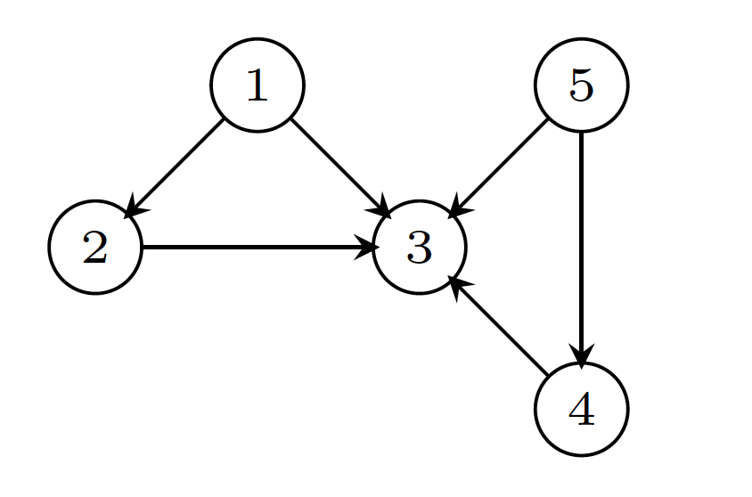

Which of the following is not a topological sort of G.

(a) 5 < 1 < 2 < 4 < 3

(b) 1 < 2 < 5 < 4 < 3

(c) 5 < 2 < 4 < 1 < 3

(d)  1 < 5 < 4 < 2 < 3

(4) An undirected graph G has n nodes. Its adjacency matrix is given by an n × n square matrix whose diagonal elements are 0’s and (ii) non-diagonal elements are 1’s. which one of the following is TRUE?

1. Graph G has no minimum spanning tree (MST)
2. Graph G has a unique MST of cost n-1
3. Graph G has multiple distinct MSTs, each of cost n-1
4. Graph G has multiple spanning trees of different costs

(5) Let G be an undirected connected graph with distinct edge weight. Let **emax** be the edge with maximum weight and **emin** the edge with minimum weight. Which of the following statements is false?

1. Every minimum spanning tree of G must contain **emin**
2. If **emax** is in a minimum spanning tree, then its removal must disconnect G
3. No minimum spanning tree contains **emax**
4. G has a unique minimum spanning tree

**2. Short Answers**

(1) Consider the following graph. If there is ever a decision between multiple neighbor nodes in the search algorithm, assume we always choose the letter alphabetically. In what order will the nodes be visited using a Breadth First Search starting from A?

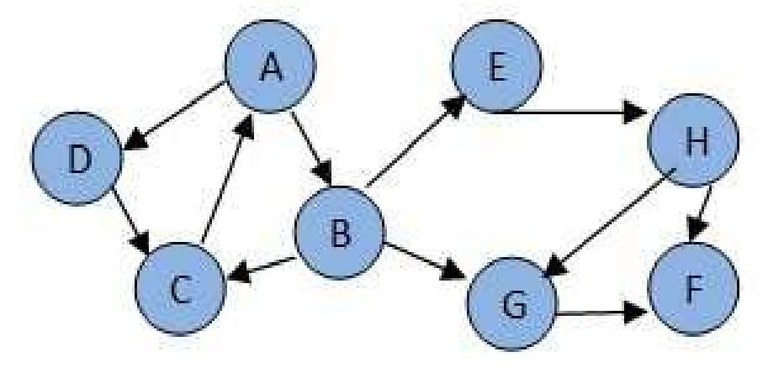

**A > B > D > C > E > G > H > F**

(2) Consider the same graph in (1). If there is ever a decision between multiple neighbor nodes in the search algorithm, assume we always choose the letter alphabetically. In what order will the nodes be visited using a Depth First Search starting from A?

**A > B > C > E > H > F > G > D**

(3) Is it true that a depth-first search of a directed graph always produces the same number of tree edges (i.e. independent of the order in which the vertices are provided and independent of the order of the adjacency lists)? Provide an example.

FALSE

3. Identify all the strongly connected components in the following directed graph:

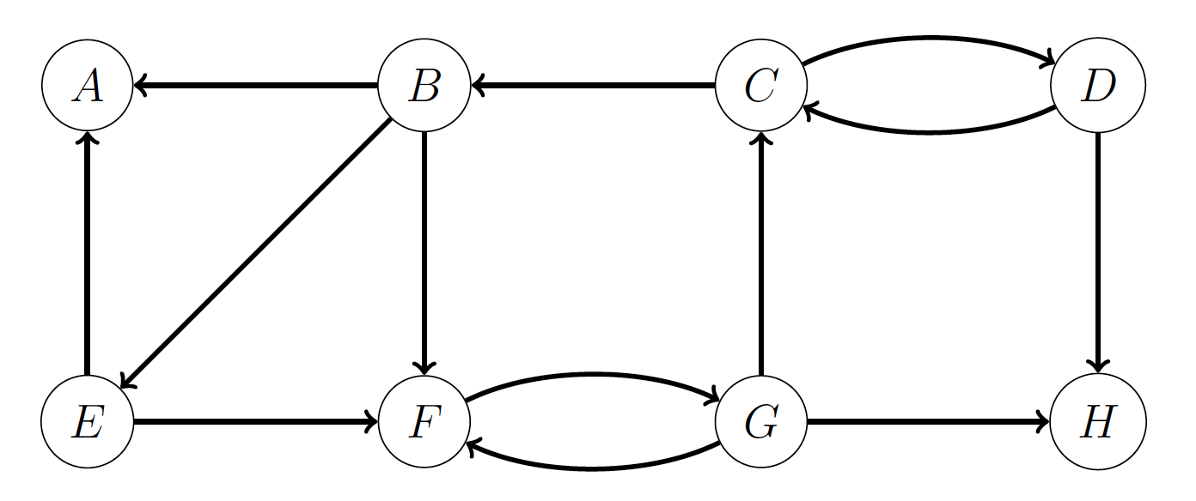

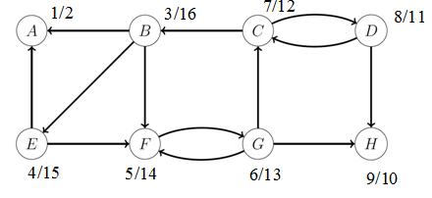

(2)Finshing time order is : B-16, E-15, F-14, G-13, C-12, D-11, H-10, A-2

(3)DFS on $G^{T}$ start from the order above:

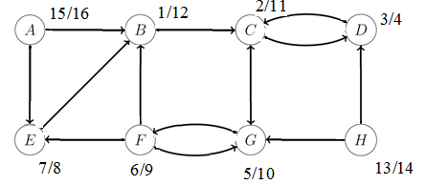

(4)We get three SCC {{B, C, D, E, F, G}, {H}, {A}}

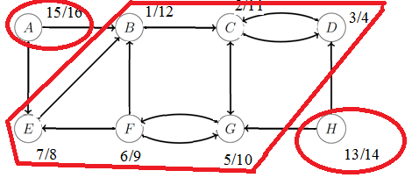

4. Given the following graph, what is the minimal cost of a spanning tree? Draw a minimum spanning tree of the graph.

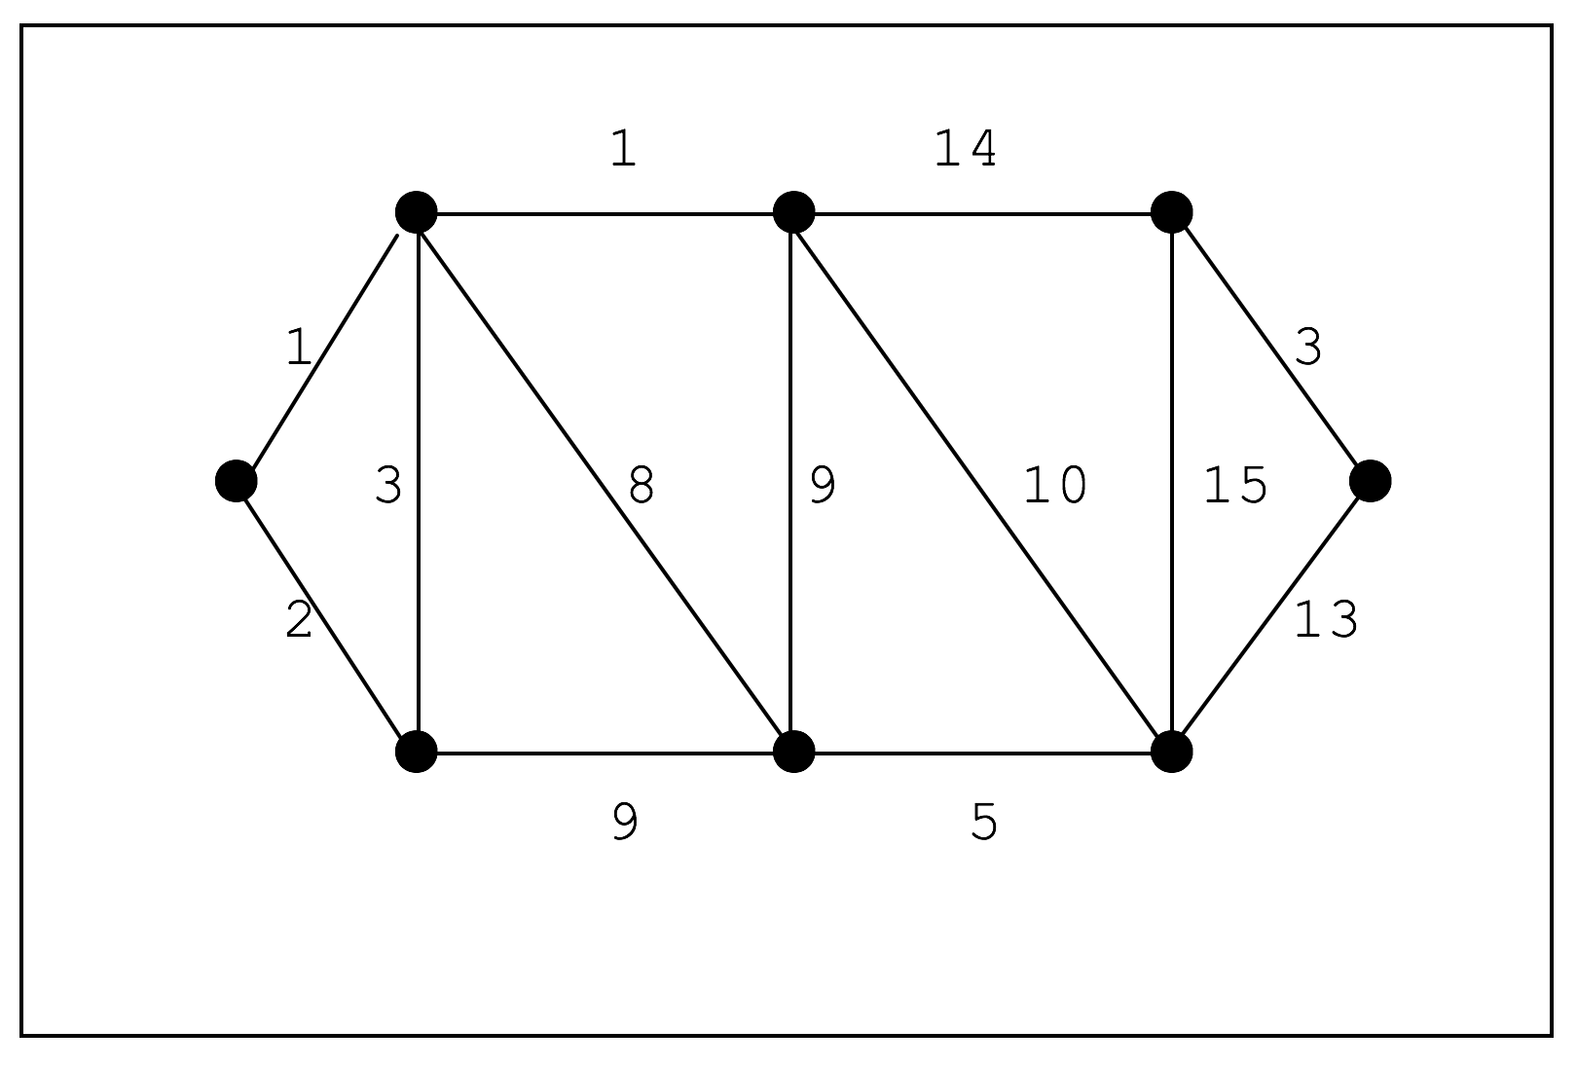MST: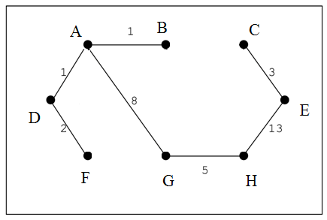

minimum cost = 1+1+2+3+5+8+13=33

5. A weighted undirected graph G  = (V; E) is an almost-tree if G  is connected, and the number of edges and the number of vertices are exactly the same (|V| = |E|). Describe an algorithm (in words or pseudo code) to compute the minimum spanning tree of G efficiently from an almost-tree G  = (V; E).

KEY:

